Memory in Motion Artwork list

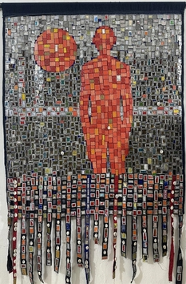 | Opa bathily  La Sentinelle des Marees , 2025  Mixed Medium, Tissue, Fragments of the soul, metal & plastic  105 x 168 cm  (C009618) | $ 10,480.00
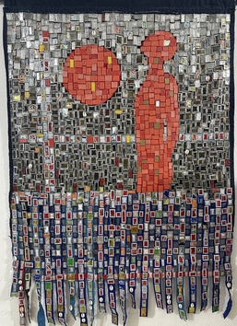 | Opa bathily  Le Gardien du Temps Suspendu , 2025  Mixed Medium, Tissue, Fragments of the soul, metal & plastic  100 x 150 cm  (C009617) | $ 10,960.00
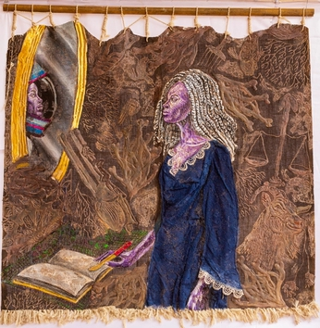 | Ibrahim Bemba kebe  Memory in the Abyss, 2025  Acrylic on Canvas  144 x 140 cm  (C009211) | € 4,310.00
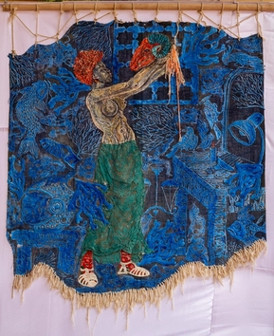 | Ibrahim Bemba kebe  Raising the Spirit Animal, 2026  Acrylic on Canvas  140 x 153 cm  (C009212) | € 5,310.00
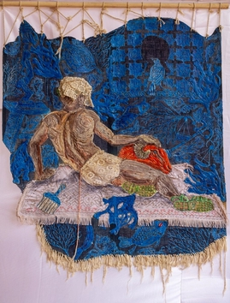 | Ibrahim Bemba kebe  The Aftermath, 2026  Acrylic on Canvas  142 x 160 cm  (C009210) | € 5,310.00
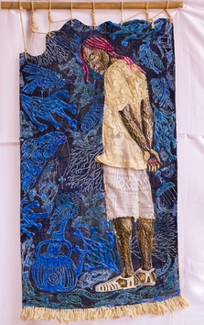 | Ibrahim Bemba kebe  Watcher of the depths, 2025  Acrylic on Canvas  72 x 140 cm  (C009213) | € 2,810.00
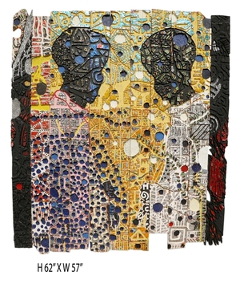 | Gerald Chukwuma  FACE ME , 2024  Mixed Media  62 x 57 in  (C007910) | $ 25,000.00
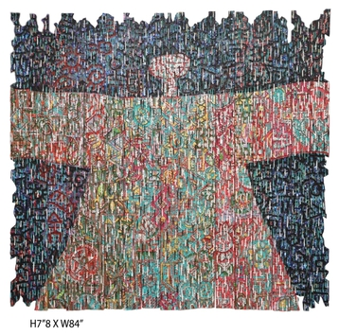 | Gerald Chukwuma  FREEDOM IN THE RAIN 2026, 2026  Mixed Media  78 x 84 in  (C007913) | $ 32,000.00
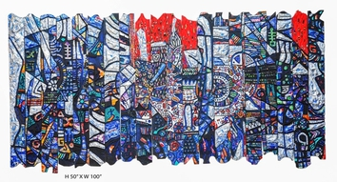 | Gerald Chukwuma  THE ICE, THE WATER AND THE FIRE 2025, 2025  Mixed Media  50 x 100 in  (C007911) | $ 30,000.00
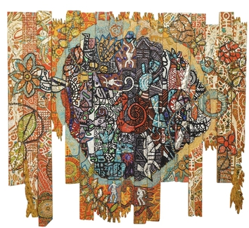 | Gerald Chukwuma  WHAT GOES AROUND, STAYS AROUND 2026, 2026  Mixed Media  75 x 84 in  (C007912) | $ 32,000.00
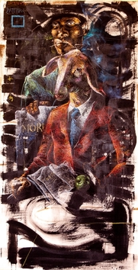 | Mwass Githinji  The Esoteric Knight , 2026  Oil Pastels & Oil Paint on Canvas  76 x 150 cm  (C009808)
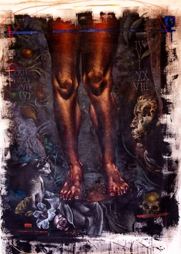 | Mwass Githinji  The Predicaments of Eve , 2026  Oil Pastels & Oil Paint on Canvas  90 x 120 cm  (C009809)
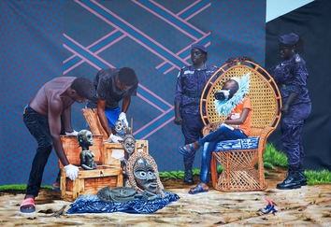 | Dieudonne Djiela Kamgang  L'inventaire, 2024  Acrylic on Canvas  287 x 205 cm  (C009705) | € 12,000.00
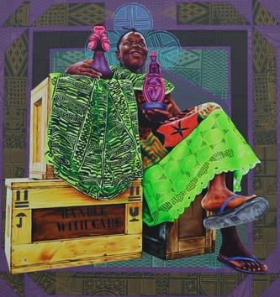 | Dieudonne Djiela Kamgang  Ma mfo Baoule, 2022  Acrylic & Screen Print on Canvas  130 x 120 cm  (C009702) | € 3,000.00
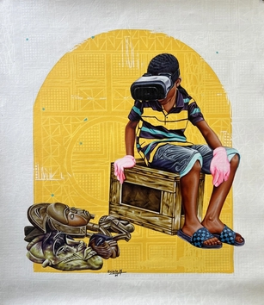 | Dieudonne Djiela Kamgang  The Oath of Heirs II, 2025  Acrylic & Screen Print on Canvas  61 x 153 cm  (C009701) | € 3,000.00
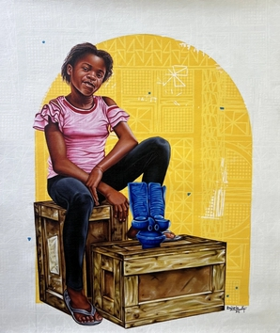 | Dieudonne Djiela Kamgang  The Oath of the Heirs I , 2025  Acrylic & Screen Print on Canvas  61 x 153 cm  (C009703) | € 3,000.00
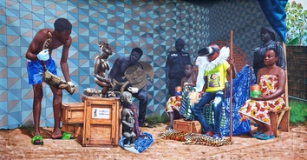 | Dieudonne Djiela Kamgang  True Beauty, 2024  Acrylic on Canvas  387 x 205 cm  (C009704) | € 13,000.00
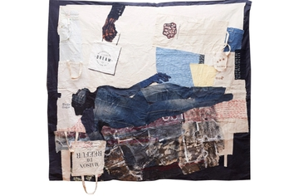 | Ange Arthur Koua  DREAM, 2023  Mixed Medium  200 x 225 cm  (C009404) | $ 25,236.00
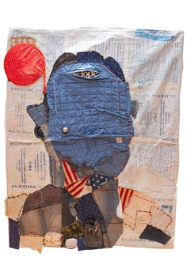 | Ange Arthur Koua  Iconoclaste, 2021  Mixed Medium  180 x 150 cm  (C009400) | $ 19,236.00
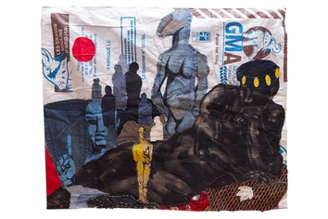 | Ange Arthur Koua  Juste pour l’Oscar (Just for the Oscar), 2023  Mixed Medium  100 x 120 cm  (C009401) | $ 8,736.00
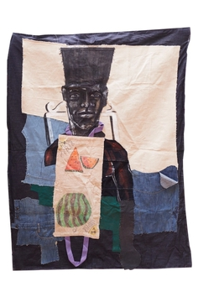 | Ange Arthur Koua  Le marchand de l’ombre (The Shadow Merchant), 2023  Mixed Medium  1450 x 110 cm  (C009402) | $ 10,236.00
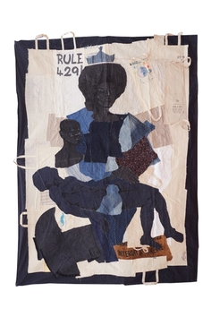 | Ange Arthur Koua  Mami Wata, 2023  Mixed Medium  280 x 210 cm  (C009405) | $ 28,000.00
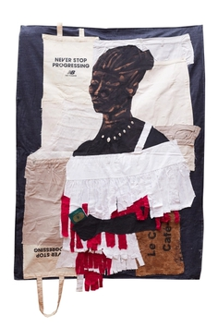 | Ange Arthur Koua  Never Stop progressing, 2023  Mixed Medium  148 x 110 cm  (C009403) | $ 10,236.00
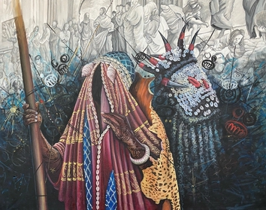 | Kenof Franck Kemkeng Noah  The Arrest - His Majesty - The Transmission, 2025  Acrylic on Canvas  94 x 74 cm  (C009303) | € 3,956.00
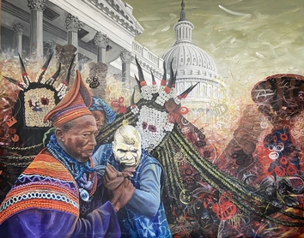 | Kenof Franck Kemkeng Noah  The Arrest - It was Destiny I , 2025  Acrylic on Canvas  200 x 160 cm  (C009301) | € 9,856.00
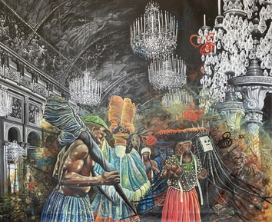 | Kenof Franck Kemkeng Noah  The Arrest - Sacred Places III, 2025  Acrylic on Canvas  200 x 160 cm  (C009302) | € 9,526.00
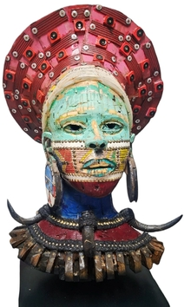 | Ndabuko Ntuli  uNdlunkulu I, 2026  Mixed Media  89 x 64 x 68 cm  (C008165)
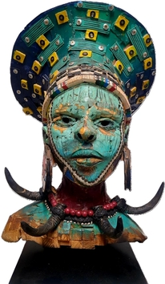 | Ndabuko Ntuli  uNdlunkulu II, 2026  Mixed Media  86 x 58 x 66 cm  (C008166)
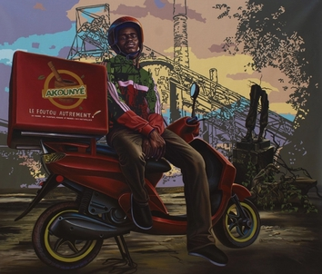 | Alexis Daniel Onguene Tassi  Akounye (eat well), 2025  Acrylic on Canvas  120 x 104 cm  (C009994)
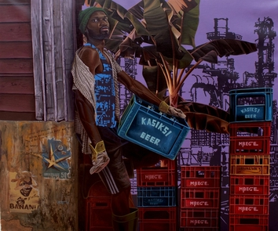 | Alexis Daniel Onguene Tassi  Behind the Cliches, 2025  Acrylic on Canvas  110 x 130 cm  (C009992)
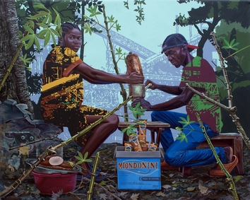 | Alexis Daniel Onguene Tassi  Garyland, 2025  Acrylic on Canvas  158 x 130 cm  (C009993)
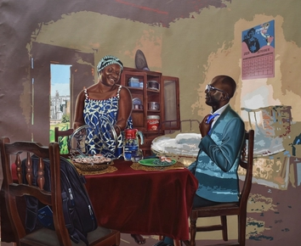 | Alexis Daniel Onguene Tassi  The Test of my Chosen One, 2024  Acrylic on Canvas  130 x 160 cm  (C009991)
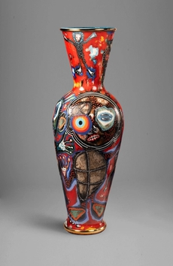 | Mederic Turay  Sacred totems series 3 , 2026  Oil, oil sticks, acrylic, coffee ,burlap, walnut ink on ceramic  144x52 cm  (C006396) | $ 11,000.00
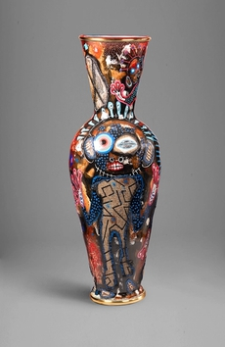 | Mederic Turay  Sacred totems series 4, 2026  Oil, oil sticks, acrylic, coffee ,burlap, walnut ink on ceramic  144x52 cm  (C006397) | $ 11,000.00
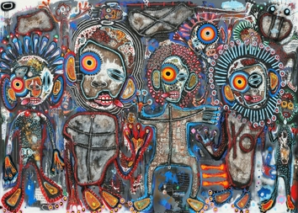 | Mederic Turay  Talking Totems “war victims”, 2026  Oil, oil sticks, acrylic, coffee, burlap, walnut ink on ceramic  250 x 180 cm  (C006395) | $ 25,300.00

